**Test Plan Document**

**How tests are organised**

The tests will be in a separate folder from the main program file, which contains the actual program of Quinterac. In that separate “test” folder lies the test codes, a predefined Valid Accounts List File and an expected final Transaction Summary File. The tests will be organised according to functionality, namely login, logout, createacct, deleteacct, deposit, withdraw and transfer. Unit testing will first be applied to each function in the functionality, before the entire functionality is tested as a whole. The functions will be tested in order of login, logout, createacct, deleteacct, deposit, withdraw and transfer. This is because login and logout are required before other transactions can be performed, and deposit, withdraw and transfer can only be performed with account creation. All of the functionalities will then be integrated together and tested with integration testing. An example of our planned directory structure is shown below.

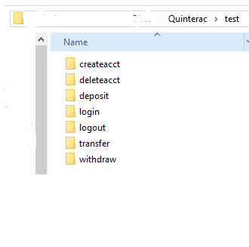

**How tests will be run**

The tests will be run using JUnit test cases. The test codes will call functions from the actual Quinterac program. Since some functionalities may be interdependent on others e.g. login has to be done before createacct, stubs will be used for such test cases. This allows us to isolate each function and test independently.

**How the output will be validated**

Assertions in JUnit will be used for validating the outputs. The outputs of the tests will be matched against the expected outputs detailed in the test cases to determine if the functions are working.

**How results will be stored and organised**

After a test case is run, the test number and the output of the assertion in the test case will be written in a separate file. This file can be used for reporting and comparison with future runs if changes to the functions are made.